

STUDENT DETAILS

Student Name: Rickson Mwangi
Admission Number: BSCCS/2024/54222
Course: COMPUTER SCIENCE
Unit Code: BIT3208
Unit Name: ADVANCED WEB DESIGN AND DEVELOPMENT
Lecturer Name: Lec Nyoro
Semester: Year 3, Sem 2
PROJECT DETAILS
Project Title: Student Management System
Tech Stack: Node.js, Express.js, MySQL, JWT

GITHUB LINK

LINK: https://github.com/ricksonmwangi/BIT3208_Week4-5_Project

Table of Contents
Week 1: Local Environment Setup 2
Title: Installation and Testing of Local Development Environment 2
Week 2: Wireframes and GUI Design 4
Title: User Interface Planning and System Design 4
Design Decisions 4
Page Inventory 5
Navigation Flow 5
Week 2 Checklist 5
Week 3: JavaScript and NodeJS Basics 5
Title: Frontend Interaction and Backend Foundations 5
Week 4: Server-Side Components and Backend Development Foundations 11
Required Evidence: 11
Week 5: Database Components and CRUD Operations 14
Implementing Database-Driven Application with Full CRUD 14

Week 1: Local Environment Setup

Title: Installation and Testing of Local Development Environment

Required Evidence:

Fig 1: Node.js version confirmed in terminal.
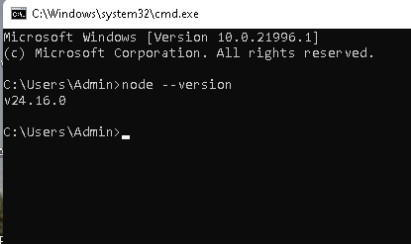

Fig 2: Apache and MySQL Running.
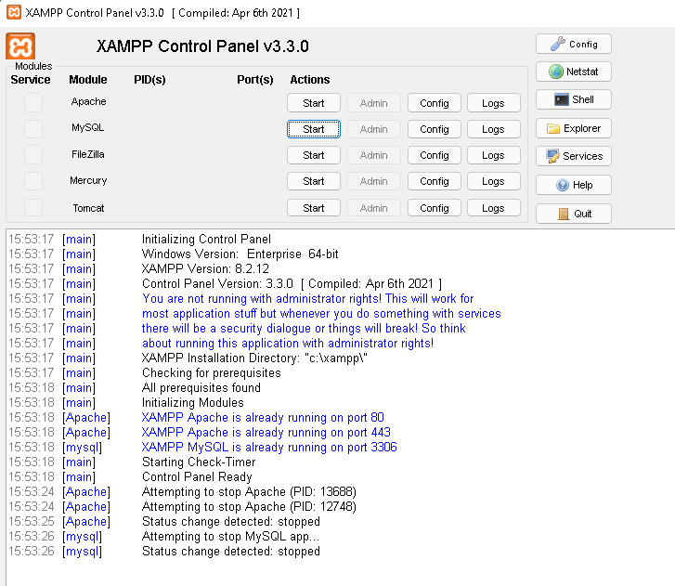

Fig 3: Hello World Test Page at http://localhost.
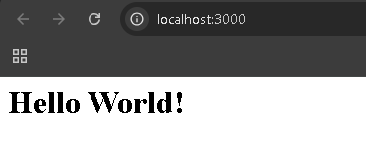

Fig 4: MySQL Connection Script (db-test.js) executed successfully.
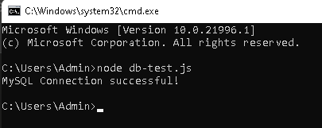

Fig 5: GitHub Repository Created — first commit pushed.
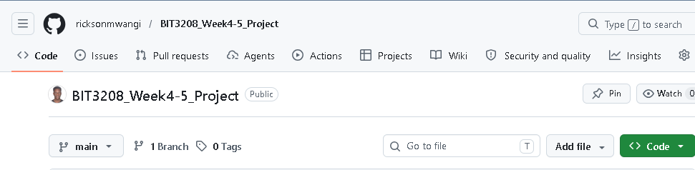

Student Reflection:

The environment was pre-configured prior to the semester, so this week focused on systematic verification rather than installation. Confirming each component , Node.js, XAMPP, MySQL, and GitHub clarified how the pieces fit together. A key insight was understanding why a connection pool is preferable to a single connection per HTTP request. Setting up version control from day one reinforced that GitHub is a non-negotiable first step in any project.

Week 2: Wireframes and GUI Design

Title: User Interface Planning and System Design

Design Decisions
Element | Decision
Colours | White background, dark navy accents
Typography | Inter / Arial – clean, readable on all screens
Navigation | Left sidebar (desktop), hamburger menu (mobile)
User Roles | Admin (full CRUD) · Student (read-only)
Layout | 12-col grid, max-width 1200px
Forms | Single-column stacked labels for accessibility
Data Tables | Sortable, paginated (10/page), inline action buttons

Page Inventory
Ref | Page | Details
W2-1 | Login Page | Email, password, submit button, error state
W2-2 | Dashboard | Sidebar nav, student table, Add/Edit/Delete buttons
W2-3 | Add Student modal | Admission No, Full Name, Email, Course, Year
W2-4 | Mobile breakpoint | Sidebar hidden, hamburger visible, table scrollable
W2-5 | Style guide | Hex colours, font scale, spacing, button states

Navigation Flow
Login → Dashboard (Student List) → Add / Edit / Delete Student
Unauthenticated users redirect to Login. JWT expiry triggers automatic logout.

Week 2 Checklist
- Wireframes created in Figma for all core pages
- Navigation flow and user roles defined
- Responsive breakpoints specified
- Style guide documented
- GitHub updated with Week 2 folder

Student Reflection:

UI design without writing any code proved more demanding than expected. Laying out information from a user's perspective highlighted how easily a screen becomes cluttered. Simplifying to the most relevant actions per view improved the flow significantly. Defining Admin and Student roles early clarified which data required protection, feeding directly into the JWT authentication design for Week 4.

Week 3: JavaScript and NodeJS Basics

Title: Frontend Interaction and Backend Foundations

Required Evidence:

Fig 1: JavaScript Form Validation/Interaction. 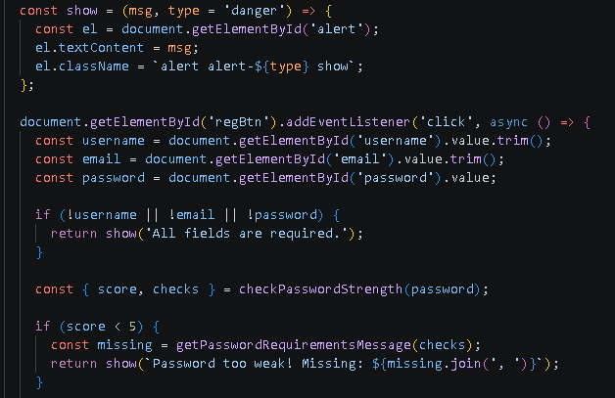

Fig 2: Password Strength Checker — regex-based real-time indicator. 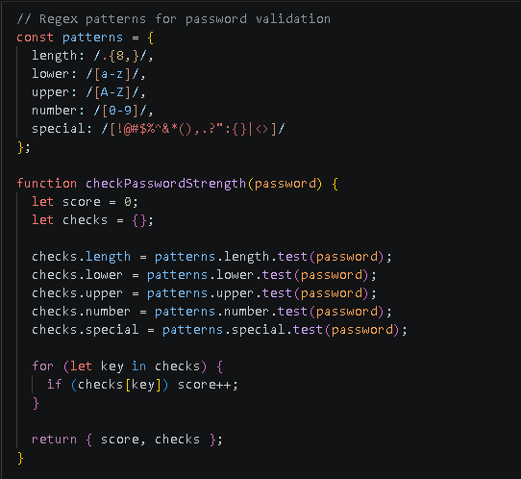

Fig 3: NodeJS Syntax Practice — variables, conditionals, foreach loop.
1.variables.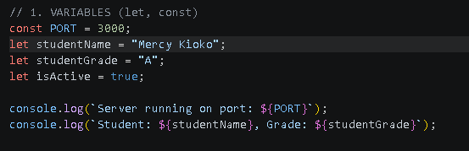

2.conditonals.
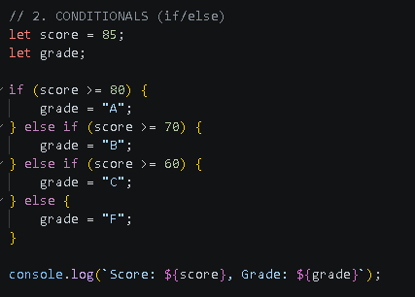
3. For each loop. 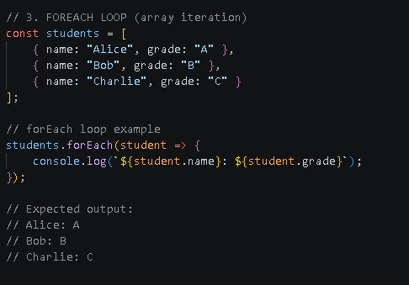

Fig 4: Database Connection Script — mysql2 connection pool. 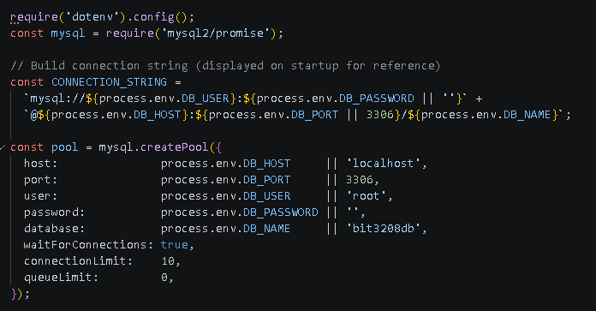 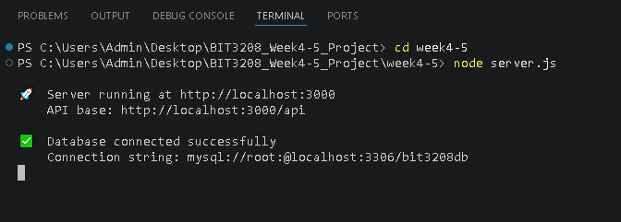

Fig 5: Dynamic User Input Handling — Express POST route returning form data.
1.Register POST routine.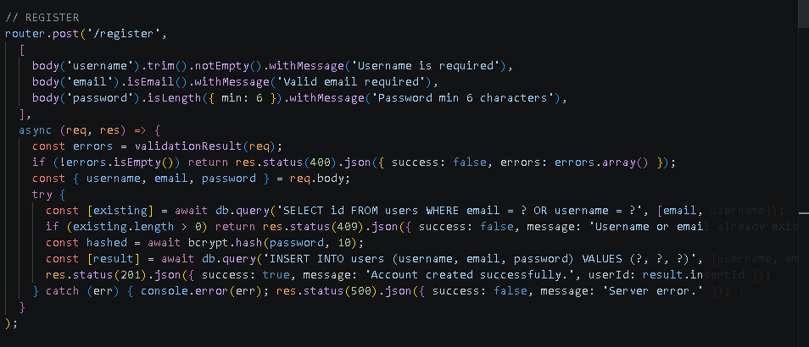
2.Login POST routine .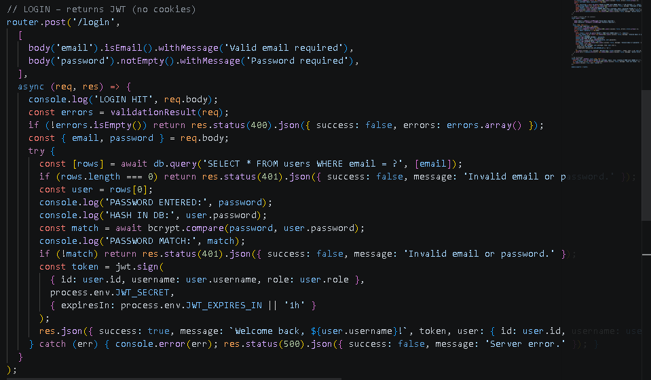
3.Student POST routine. 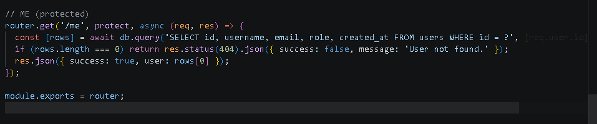

Student Reflection:

Implementing validation on both sides clarified their distinct roles: client-side improves user experience and reduces unnecessary requests; server-side is the actual security layer. The password strength checker was a valuable introduction to regular expressions. Connecting that logic to the mysql2 connection pool gave a complete picture of how the full stack communicates.

Week 4: Server-Side Components and Backend Development Foundations

Required Evidence:

Fig 1: Login Form UI.
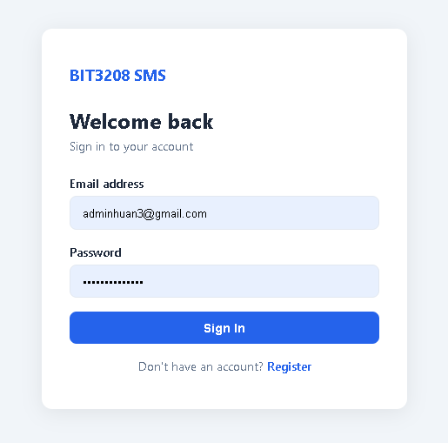

Fig 2: Registration Form with Password Strength Validation.
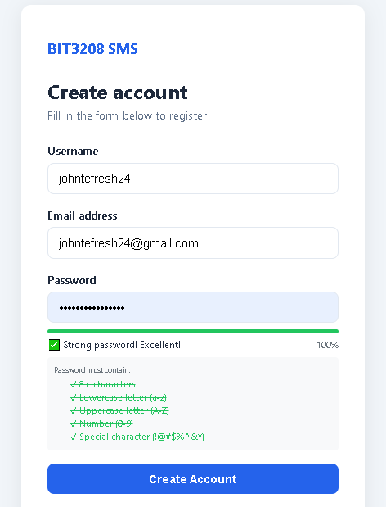

Fig 3: API Response from POST /api/auth/login showing JWT token (DevTools).
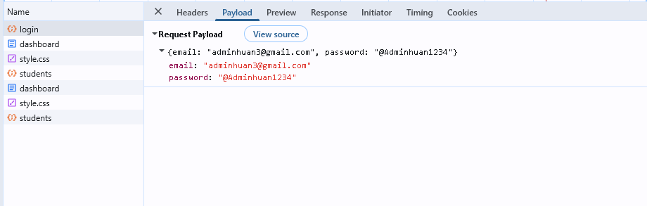

Fig 4: Response Headers confirming HTTP 200 OK from Express server (DevTools).
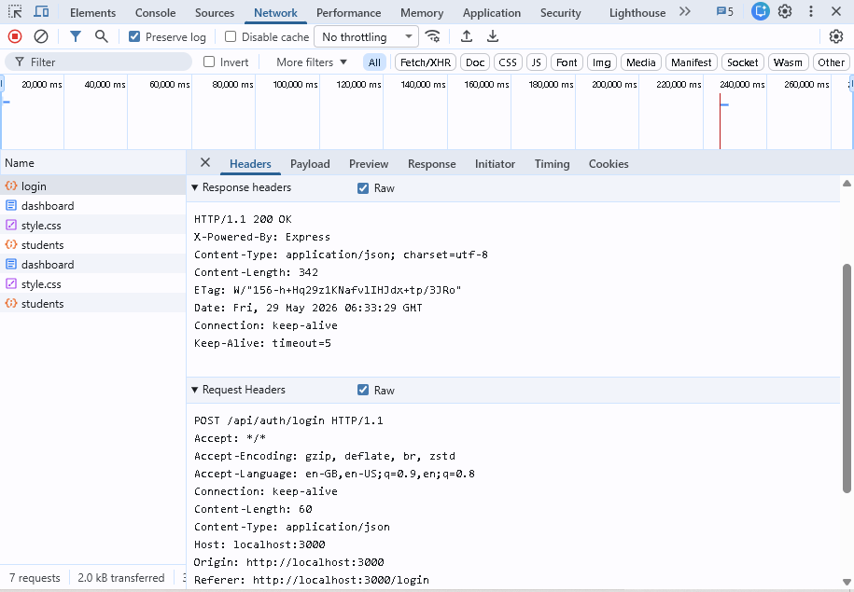

Fig 5: JWT Token stored in localStorage — DevTools > Application > Local Storage.
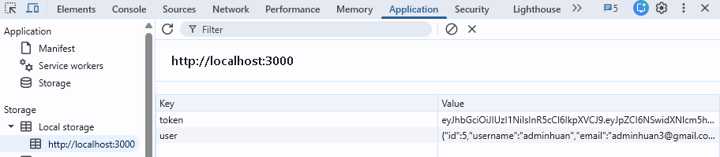

Fig 6: Project Folder Structure showing config/, middleware/, routes/, public/.
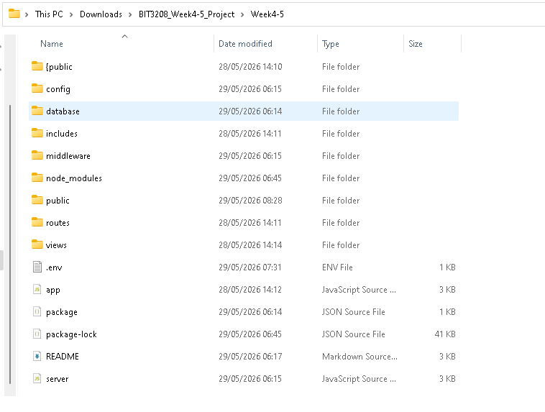

Student Reflection: Week 4 was the most technically involved week. The key distinction between PHP sessions and JWT shaped the architectural decision: sessions store state on the server while JWT carries signed user data in the token itself, leaving the server stateless. This stateless approach suits an API that may later serve a mobile client. Handling token expiry and logout manually in the frontend deepened understanding of the full authentication flow end to end.

Week 5: Database Components and CRUD Operations

Implementing Database-Driven Application with Full CRUD

Required Evidence

Fig 5.1: phpMyAdmin showing bit3208db database and tables created.
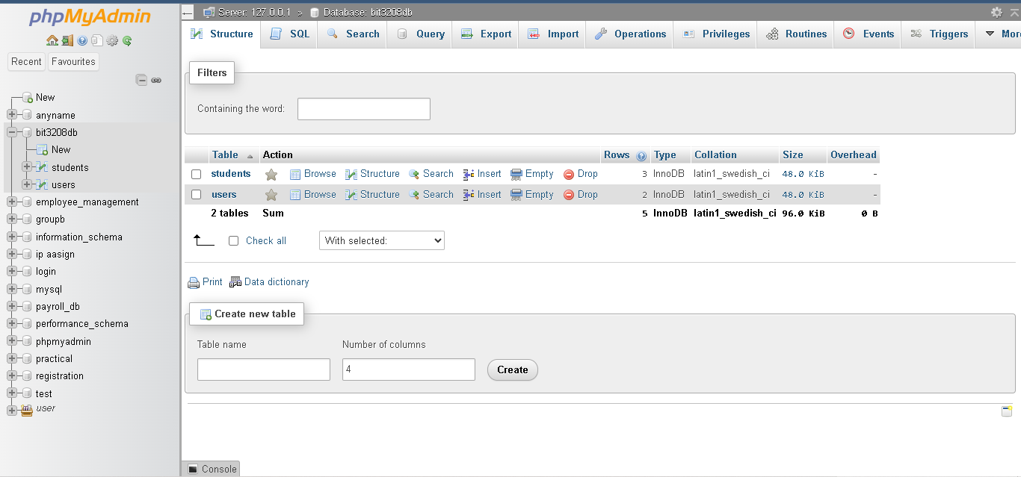

Fig 5.2: students table — rows showing id, admission_no, full_name, email, course, year_of_study.
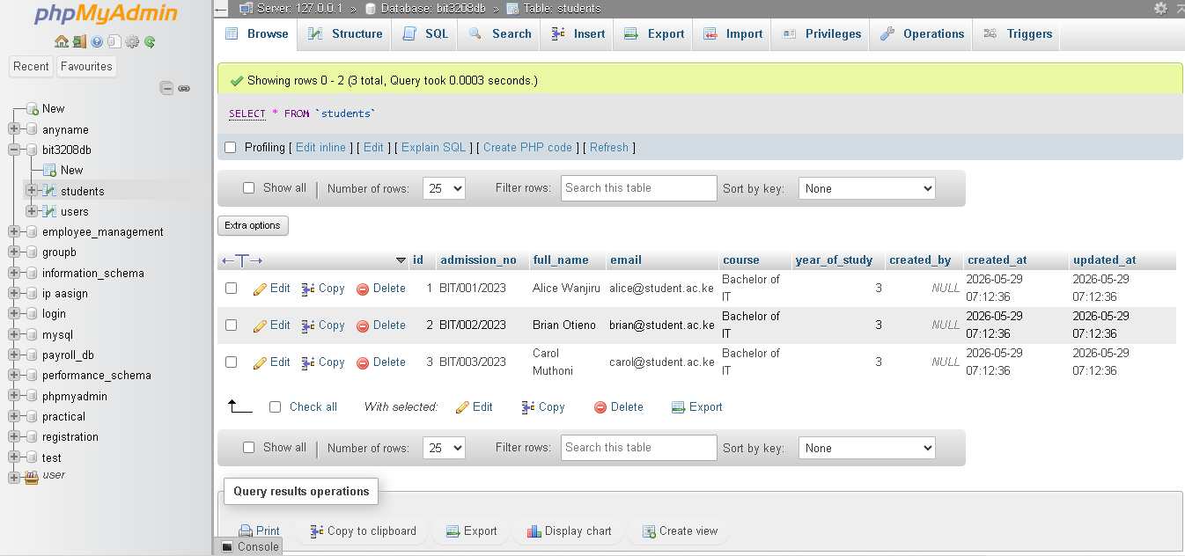

Fig 5.3: Dashboard displaying live student records loaded from the database.
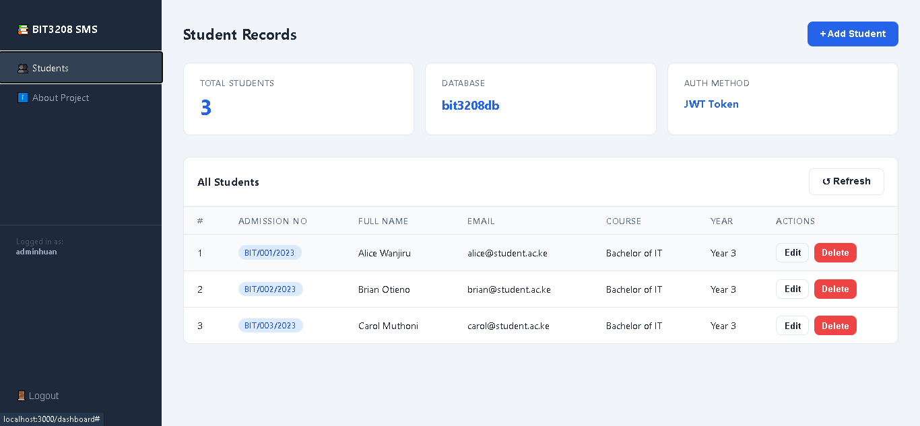

Fig 5.4: Add Student Modal — form fields before saving new record.
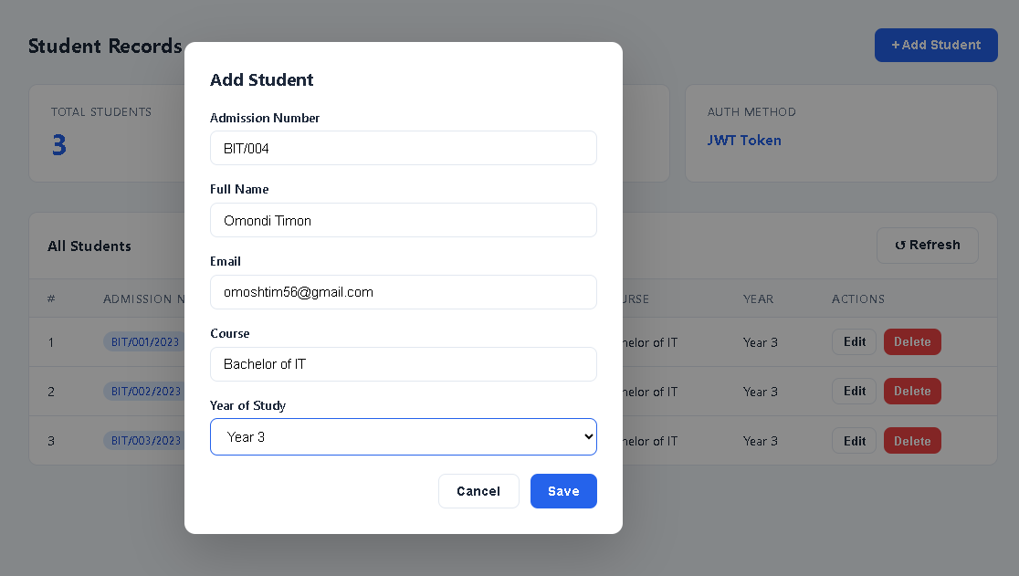

Fig 5.5: Dashboard after Create — new student (BIT/004, Omondi Timon) in the table.
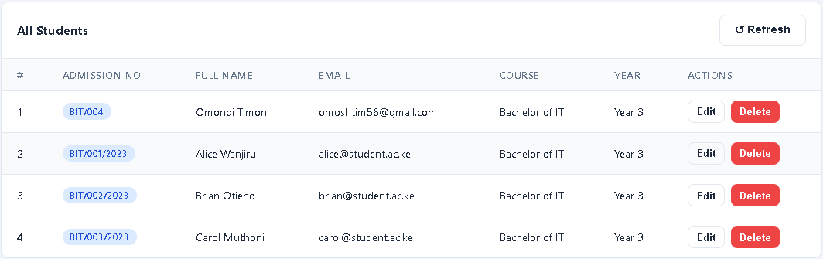

Fig 5.6: Delete Confirmation Dialog — confirming permanent removal of a record.
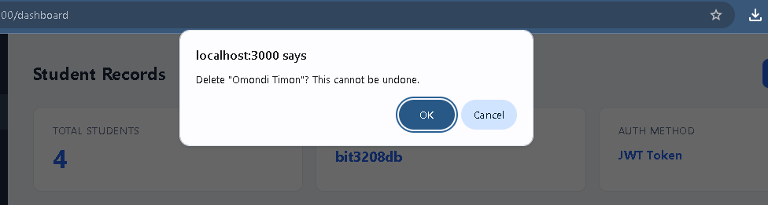

Fig 5.7: Dashboard after Delete — record removed, green 'Student deleted.' toast visible.
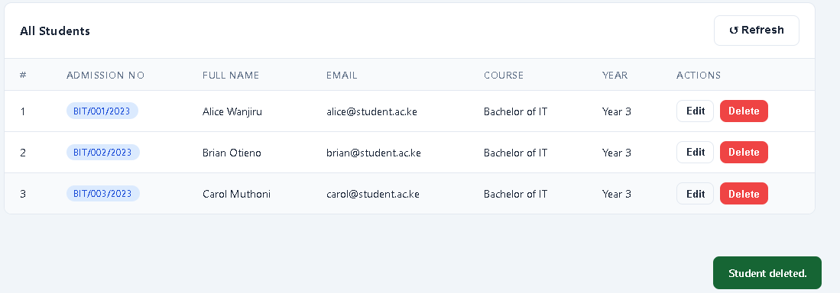

Student Reflection:

CRUD brought all previous weeks together into a tangible result. Careful schema design such as setting admission number as UNIQUE offloaded duplicate-entry validation to the database itself, reducing application-layer logic. The hardest decision was whether to hard-delete or soft-delete records; hard delete was chosen for simplicity, with soft deletion noted as a future improvement. Seeing live data populate the dashboard after a POST request was a satisfying milestone confirming the full stack was communicating correctly.

